Artists’ Residency Programme (ARP)

The Process Room
West Wing, First Floor Galleries, Irish Museum of Modern Art

The function of the Process Room is to reveal the processes in the creation, exhibition and consideration of contemporary art, which are often hidden from the public. The Process Room facilitates access to the ongoing practice of artists currently on residence at IMMA. This residency programme is located in the studios adjacent to the main Museum building where several studios are allocated to both national and international artists. The Process Room is used on a rotating basis and participating artists receive a two-week period to display projects.

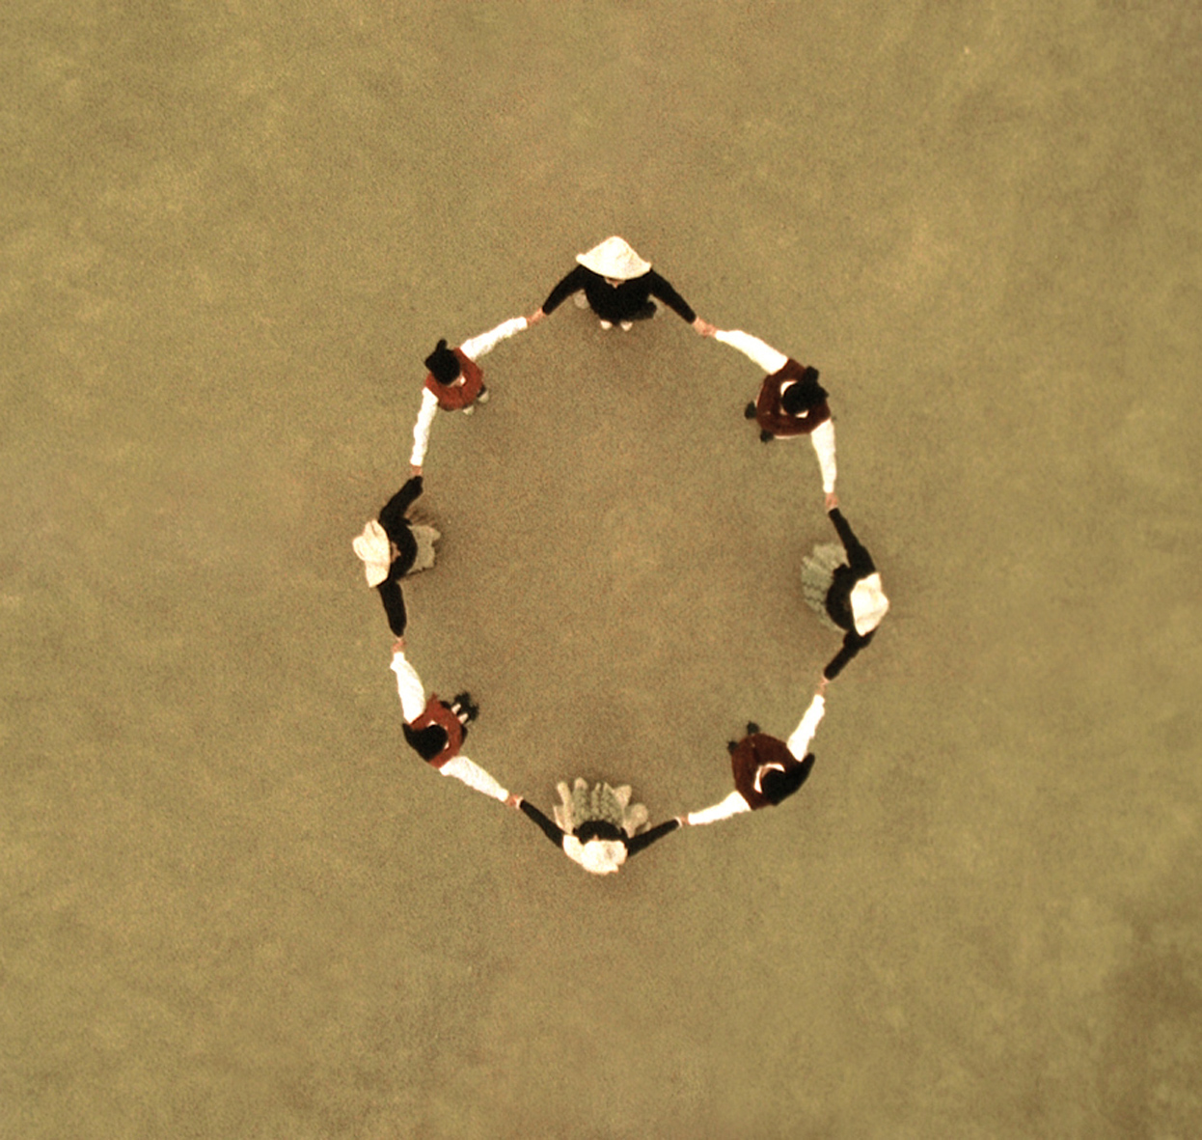

Alberto Peral
Spain _ Studio 3a

Bailando

10.07.07 – 22.07.07

_{Sardana comienzo, 2007}
The filming in 16mm of a series of dances from the repertoire of a Catalan folkdance troupe is the starting point for the project on show in the Process Room; the work was originally created for “Productions” at the Museo Nacional Centro de Arte Reina Sofía earlier this year. They are dances whose origin is uncertain, though the choreography as known today is most likely 19th century. Their initial meaning seems to be a form of communication with the cosmos since the best viewpoint is from above. They are not danced as a performance but rather as a ritual where the spectator does not exist as such. The overhead position of the camera enables us to appreciate the structures executed by the dancers. The result shows that these patterns relate to molecular structures as well as to Baroque domes and Indian tantric diagrams.
“I am interested in dance as construction, as architecture, as to how the rhythms are put together with an internal, closed, unitary structure. Two dances have been selected for this exhibition, chosen for their circular structure. The dancers revolve and create forms that can symbolize the sun, the moon, and the stars.”
The aim of these videos is not merely testimonial or documental, but rather that the dances should become an expanding diagram, a nucleus or energy point, a mantra, in which music, form and dance create a whole, a generating principle.
Peral belongs to a generation of artists who appeared in the early nineties and were decisive in the renewal of Spanish art at the beginning of the 21st century. Since his first solo exhibition at the Fundació Joan Miró in Barcelona (1992), Peral has followed a path of conceptual coherence and an urge for formal experimentation which have led him to make use of a wide range of mediums from drawing, photography and sculpture, to installation and video. This diversity enables him to forge an exciting, poetical encounter between the beauty of the simplest, most essential forms and the symbolic power they contain. Ovoid forms as germinal symbols, circularity, rotation, the earth-heaven axis, light and colour are the fundamental elements with which Peral builds on the subtle poetics of the universe, of a sense of space and time that fans out in multiple directions and expands with his experience of other places and journeys. Peral’s works relate to the creation of the universe and, by extension, humanity, nature, life and death.

For more information on any aspect of the Artists’ Residency Programme please contact Janice Hough, Artists’ Residency Programme Co-ordinator, Tel + 353-1-612 9905 or Email janice.hough@imma.ie, Website www.imma.ie

