Artists’ Residency Programme (ARP)
The Process Room
West Wing, First Floor Galleries, Irish Museum of Modern Art

The Process Room facilitates access to the ongoing practice of artists currently on residence at IMMA. This residency programme is located in the studios adjacent to the main Museum building where several studios are allocated to both national and international artists. The Process Room is used on a rotating basis by the artists participating on the programme.

Almut Linde
Studio 6a _ Germany

IMMA SCULPTURES
16.09.08 – 28.09.08

Events related to LINDE’S PROCESS room are listed overleaf

For her works IMMA SCULPTURES, Almut Linde turns everyday events and forms into sculptural art works. Linde focuses on seemingly uneventful activities such taken from the overall process of running an art museum: storage, cleaning, putting up and taking down an exhibition. Linde also engaged with a person who would not usually be a regular visitor to the Museum.

The works shown in the process room represent a number of sculptural events within the social context of IMMA. Formerly unnoticed occurrences are captured by means of photography, video and installation. The beauty of these occurrences are not the result of coincidence or mere aesthetics, but the result of the perspective on movement, leading to form, offered by the artist.

Linde considers her work a logical evolution of Jackson Pollock’s action painting, by using the flow of events as a fundamental part to the forming process of her artworks, which are all based within social space.

Forthcoming exhibitions for Almut Linde include: Almut Linde/Matadero, Abierto x Obras, Matadero Madrid, Spain; Almut Linde/HAP Grieshaber Prize, Künstlerbund, Berlin, Germany; Manson 1969, Hamburger Kunsthalle, Germany and Deadlines, Von der Heydt-Museum, Wuppertal, Germany. In 2008 Almut Linde was awarded first prize from Stiftung Kunstfonds: the HAP Grieshaber Prize from the VG Bild-Kunst, Bonn, Germany and the Grant for Contemporary Creation, Matadero Madrid, Spain. Linde recently participated in the International Triennial of Contemporary Art, National Gallery, Prague, Czech Republic.

Description of some of the works on show in the Process Room:

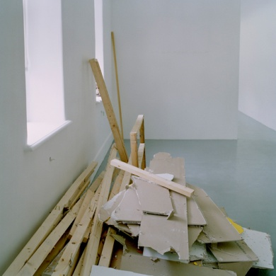
Dirty Minimal #56.1 – Eismeer

In the series of photographs Eismeer 1 – 3, piled up waste materials from torn down walls form a natural landscape. The German word ‘Eismeer’ means Polar Sea; a famous motif of German romantic painter Caspar David Friedrich. The title alludes to the similarities between the formative creation of ice shelves and the dismantled plaster walls illustrated.
Eismeer 1, colour photograph, 120 x 120 cm, 2008
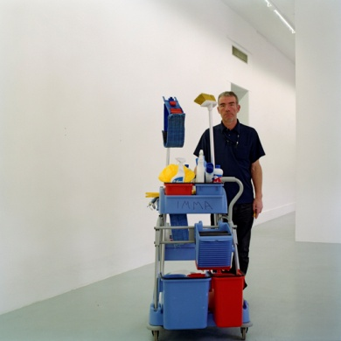
Dirty Minimal #55.4 – Moment

In Moment 1 and Moment 2, a member of the Museum’s cleaning staff and his temporarily stored cleaning tools, hold still for a photo and become an eternal moment. The silence in the picture reveals the inherent ambiguousness of things. Value/meaning is attributed to things; it is not an inherent part of the thing itself. Grace can be found in cleaning materials and people dealing with them, they become ephemeral sculptures fixed by the photograph.

Moment 1, colour photograph, 120 x 120 cm, 2008

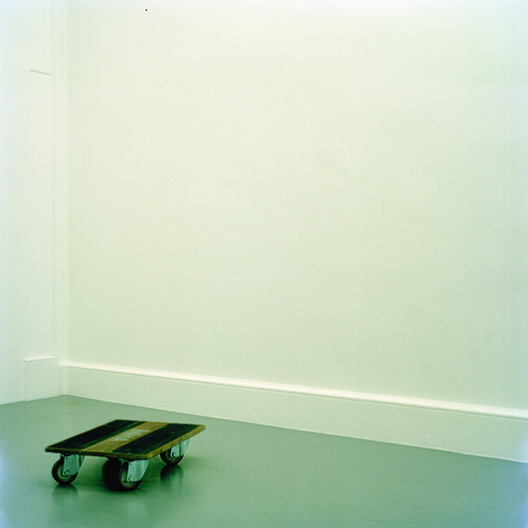
Dirty Minimal #55.2 – Eternity

In the series of photographs, Eternity, Linde captures dormant tools from the process of preparing an exhibition. As they are put down without any aesthetic or sculptural intent, they represent perfect gestures in the romantic sense described by Heinrich von Kleist in his essay “On the Marionette Theatre.” In this image the perfect gesture is the result of functional processes. In Linde’s philosophy, functional processes can become perfect gestures, like nature, because they are not disturbed by will or the deliberate intention to create form.
Eternity 1, colour photograph, 120 x 120 cm, 2008

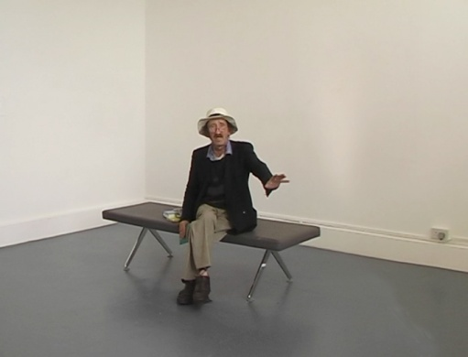
Dirty Minimal #57.1 – Poetry

In POETRY a visitor is brought to the Museum to recite poems in the white of an empty, clean museum room. He presents a living sculpture in the sense that he himself is showing the conditions of his actual state of being – a poet living on the streets of Dublin.
Poetry, DVD Video, 6:51 min 2008

Events related to Almut Linde’s Process Room:

OPEN STudio: Friday 19th September, 8:30PM – 9:30PM, arp sTUDIOS, imma
As part of Culture Night Linde, along with four fellow participants on the ARP; Niamh O’Malley, Charlotte Moth, Sean Lynch and Rhona Byrne will open their doors to the visiting public at IMMA as part of the night’s events.

Talk/performance: Friday 26th September at 5pm, The Process Room, IMMA
As part of her project IMMA SCULPTURES Almut Linde will hold a talk/performance about the work she has created at IMMA. The event will be approximately 20 minutes in duration.
All welcome. No booking needed.

Further information on Almut Linde’s practice can be found at www.almutlinde.com.
For more information on any aspect of the Artists’ Residency Programme please contact Janice Hough, Artists’ Residency Programme Co-ordinator, Tel + 353-1-612 9905 orj Email janice.hough@imma.ie. Website www.imma.ie

