Artists’ Residency Programme (ARP)

The Process Room

West Wing, First Floor Galleries, Irish Museum of Modern Art

The function of the Process Room is to reveal the processes in the creation, exhibition and consideration of contemporary art, which are often hidden from the public. The Process Room facilitates access to the ongoing practice of artists currently in residence at IMMA. This residency programme is located in the studios adjacent to the main Museum building. Several studios are allocated to both national and international artists and the Process Room is used on a rotating basis to display a taste of what is ongoing in the studio environments.

Further information on ARP can be found at www.imma.ie.

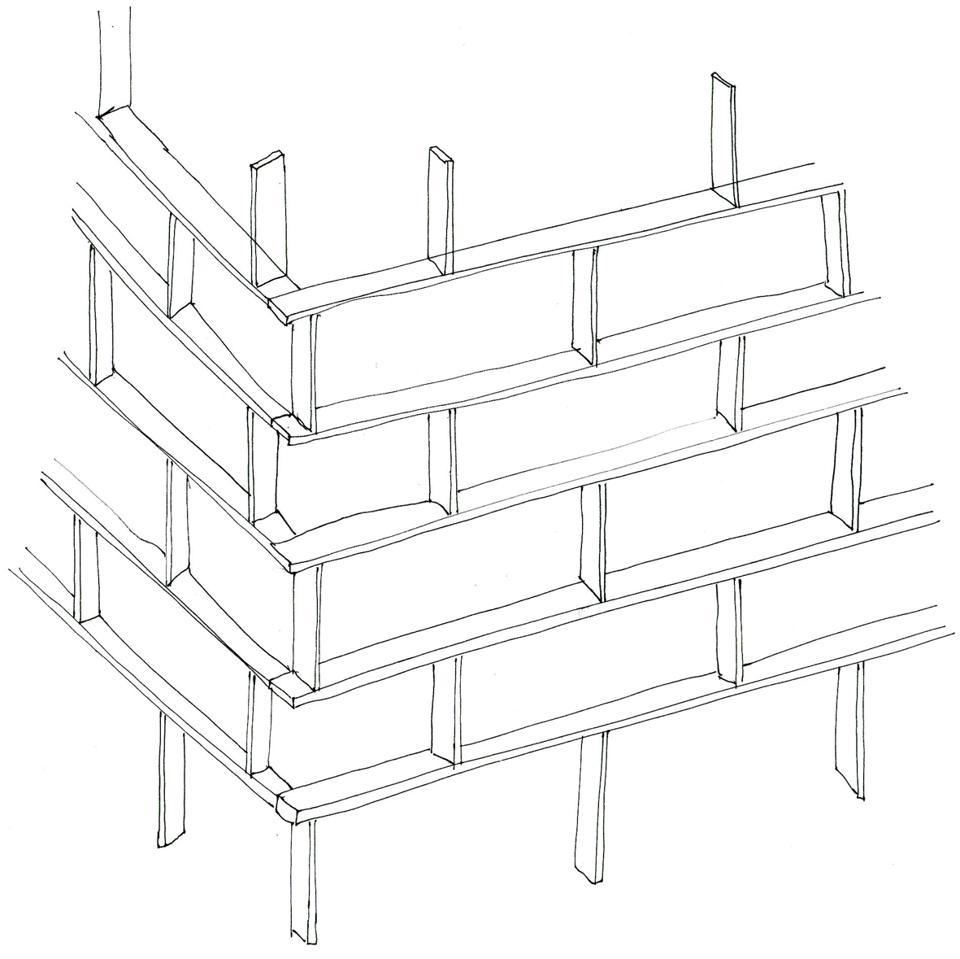

Anna Barham (UK)
Studio 6a

Trod Silver Bog Again
15th – 27th November 2005

There are always multiple possibilities for an element to be used and placed within a space, creating different relations, contexts and counterpoints. Normally an exhibition only allows for one of these possible solutions to be realised, but the process room, by its nature and close proximity to the studio, allows for a rotation and re-cycling of work over the two week period of the show – for variations and for bleeding between separate pieces, for relations to evolve in time.

The wooden structure acts as both a way to slow down entry to the space and also as a site or stage for other pieces of work that will be made on or fixed to it. The other pieces are made from things that I have had lying around or have caught my attention in Dublin – rolled up magazine pages with their found colours and textures, sellotape and paper, postcards, paint buckets, wood and cement. These simple materials have an immediate familiarity and tactility. They are ‘everyday’ and therefore often overlooked. Our lives exist in the everyday but the act of looking closely at it is subversive.

The postcard of the old entrance to Coombe Lying-in Hospital is for visitors to pick up and take away - a souvenir. Making the image into a postcard attempts to draw attention to something that is passed by. But the postcard itself is a throwaway object, a piece of ephemera, replaying the observed / overlooked, given and taken away.

For further information on Anna Barham’s work please go to www.annabarham.net.
Anna will be on residence at IMMA until the end of January 2006.

