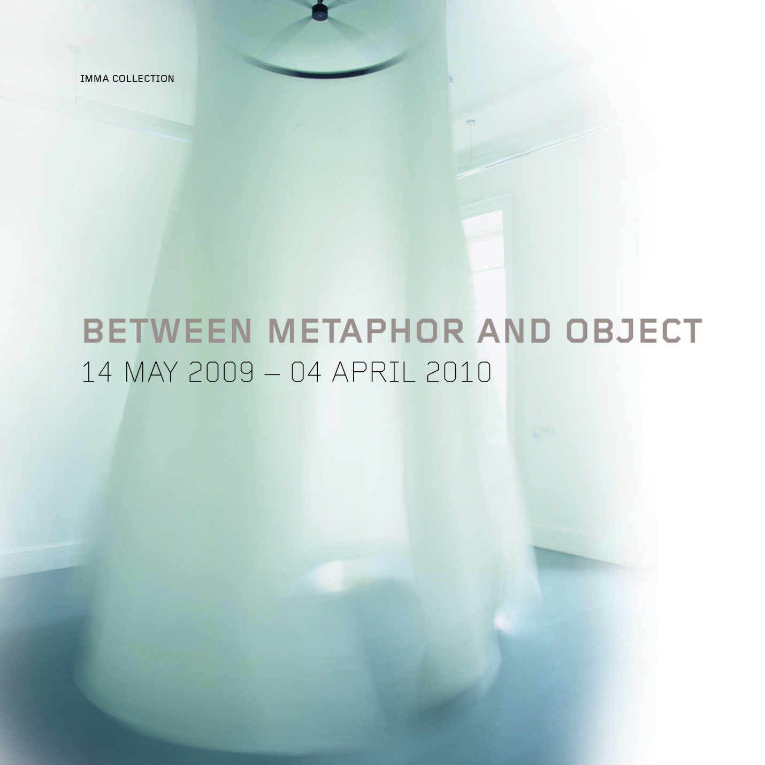

List of works, Alphabetical by Artist’s surname
Between Metaphor and Object opened on 14 May 2009, the following list of works is correct after a change to a number of works on paper which was made in November 2009. For the previous list of works, please contact info@imma.ie

Stephan Balkenhol
Large Head, 1991
Wawa wood
120 cm high. Base 100 cm high.
Collection Irish Museum of Modern Art
Purchase, 1992

Maud Cotter
In the Grace of its own Shadow, 1995
Stone, lead, copper, steel and pvc
228 x 82 x 35 cm
Collection Irish Museum of Modern Art
Purchase, 1995

Barry Flanagan
Carving No. 6a, 1982
Travertino romano chiaro marble
83 x 123 x 93 cm
Collection Irish Museum of Modern Art
Purchase, 2006

Douglas Gordon
Above All Else, 1991
Vinyl and matte emulsion
Varying dimensions
Collection Irish Museum of Modern Art
Loan, Weltkunst Foundation, 1994

Ann Hamilton
Filament II, 1996
Organza fabric, steel mount with electronic controller
Curtain height 426.72 cm, overall installation height variable
Collection Irish Museum of Modern Art
Purchase, 2002

Siobhán Hapaska
Bond, 1999
Fiberglass, Irish basalt, reindeer moss, two-pack lacquer and electrical components
180 x 120 x 70 cm
Collection Irish Museum of Modern Art
Purchase, 2000

Shirazeh Houshiary
Defence of Light, 1989
Brass, copper, pure crystal and coal
457.2 x 223.5 x 122 cm
Collection Irish Museum of Modern Art
Loan, Weltkunst Foundation, 1994

The Divided Blade is Love,1994
Lead and platinum
33 x 33 x 99 cm
Collection Irish Museum of Modern Art
Loan, Weltkunst Foundation, 1996

Ilya and Emilia Kabakov
The Mysterious Exhibition, 1998
Hospital bed, chairs, bedside locker, miniature theatre
Installation, dimensions variable
Collection Irish Museum of Modern Art
Purchase, 1999

Anish Kapoor
From Untitled, 1994
A series of Spitbite etchings (pub. Paragon Press)
50 x 58 cm
Collection Irish Museum of Modern Art
Loan, Weltkunst Foundation, 1995

Richard Long
Kilkenny Limestone Circle, 1991
Limestone
400 cm diameter
Collection Irish Museum of Modern Art
Purchase, 1991
Avis Newman
Nests There Are..., 1986-7
Drawing on muslin, painted box, bird’s wing and honeycomb
38 x 33 x 8 cm
Collection Irish Museum of Modern Art
Loan, Weltkunst Foundation, 1995

Lucia Nogueira
Untitled, Undated
Watercolour and graphite on paper
38 x 28cm
Collection Irish Museum of Modern Art
Loan, Weltkunst Foundation, 1994

Eilís O'Connell
Laden, 1999
Painted cast resin
208 x 114 x 72 cm
Collection Irish Museum of Modern Art
Purchase, 1999

Julian Opie
D/889 E, 1990
Paint on wood, glass
198 x 289.5 x 208 cm
Collection Irish Museum of Modern Art
Loan, Weltkunst Foundation, 1994

Jacqueline Poncelet
Fabric, clay, wood and bronze, 1986-1987
Fabric, clay and wood, bronze and wood
96 x 191 x 32 cm
Collection Irish Museum of Modern Art
Loan, Weltkunst Foundation, 1994

Kiki Smith
Peacock, 1994
Papier mâché figure and 28 ink drawings on Nepal paper
67.3 x 44.5 x 54.6 cm
Collection Irish Museum of Modern Art
Purchase, 1997

Michael Warren
M-7 23, Homage to Eileen Gray, 2007
Machined Bronze
18 x 254 x 254
Collection Irish Museum of Modern Art
Collection of the artist

Richard Wentworth
Heist, 1983
Linen, duckdown, gilded lead, tined steel
60 x 90 x 65 cm
Collection Irish Museum of Modern Art
Loan, Weltkunst Foundation, 1994

Gosse, 1984
Galvanised steel, aluminium cable
28 x 66 x 48 cm
Collection Irish Museum of Modern Art
Loan, Weltkunst Foundation, 1994

Rachel Whiteread
Demolished
12 Duo-tone screenprints
48.5 x 74 cm each
Collection Irish Museum of Modern Art
Loan, Weltkunst Foundation, 1994

Alison Wilding
Stormy Weather, 1987
Galvanised steel, oil paint and bronze
224.79 x 115.57 x 170.18 cm
Collection Irish Museum of Modern Art
Loan, Weltkunst Foundation, 1994

Into the Dark, 1986
Wood, lead
71 x 51 x 35 cm
Collection Irish Museum of Modern Art
Loan, Weltkunst Foundation, 1996

