Artists’ Residency Programme (ARP)
The Process Room
West Wing, First Floor Galleries, Irish Museum of Modern Art

The Process Room facilitates access to the ongoing practice of artists currently on residence at IMMA. This residency programme is located in the studios adjacent to the main Museum building where several studios are allocated to both national and international artists. The Process Room is used on a rotating basis by the artists participating on the programme.

Falke Pisano
Studio 3a _ The Netherlands

A Sculpture Turning into a Conversation (Part Zero and Part One)
2 DVDs, 25 minutes, 2006

Showing in The Process Room at IMMA from
05.03.09 – 15.03.09

Courtesy: Ellen de Bruijne Projects, Amsterdam / Balice Hertling, Paris / Hollybush Gardens, London

Falke Pisano’s lecture-performances, text-based videos, objects and photocopied publications are the elements of a body of work that is distinctly induced by a practice of writing. Although mainly text-based, Pisano’s work displays a strong concern with the existence and features of concrete objects, and in particular abstract concrete objects. Using language as a means to re-think the potential of abstraction, sculpture and artistic practice she activates the abstract sculpture as a thought-generating principle and employs the idea of the unstable transforming and disintegrating object as a way to address issues concerning object-qualities, form, construction and engagement.

Falke Pisano was born in Amsterdam, The Netherlands in 1978 and she currently lives and works in Berlin. She recently had exhibitions at Grazer Kunstverein, Graz, 2009 (in collaboration with Benoît Maire); Hollybush Gardens, London, 2008 (in collaboration with Benoît Maire); Croy Nielsen, Berlin, 2008 (in collaboration with Benoît Maire); Balice Hertling, Paris (2008) and Ellen de Bruijne Projects, Amsterdam (2007). Pisano has participated in numerous group exhibitions including the first Brussels Biennale; Yokohama Triennale 2008; Manifesta 7; Trentino-Alto Adige; Word Event, Kunsthalle Basel, 2008; Object, the Undeniable Success of Operations, SMBA, Amsterdam, 2008 (co-curated with Krist Gruijthuijsen); When things cast no shadow, 5th Berlin biennial for contemporary art, Berlin, 2008; Imagine Action, Lisson Gallery, London, 2007; Das Offene Ende / The Open End, Künstlerhaus Stuttgart, 2007; Elephant Cemetery, Artists Space, New York, 2007.

Upcoming shows in 2009 include a solo at Hollybush Gardens April 2009, 53rd International Art Exhibition La Biennale di Venezia, June 2009; Modernologies, MACBA, Barcelona, September 2009 and The Malady of Writing, MACBA, Barcelona, October 2009.

Further information on Pisano can be found at www.falkeandcharlotte.org and www.edbprojects.nl.

For more information on any aspect of the Artists’ Residency Programme please contact Janice Hough, ARP Co-ordinator, Tel + 353-1-612 9905 or Email janice.hough@imma.ie. Website www.imma.ie

Falke Pisano
A Sculpture Turning into a Conversation (Part Zero and Part One)

The work currently on show in The Process Room exists both as live lecture and as a double projection with voice-over. In the video work a voice-over reads a text in which a sculpture transforms (is transformed) into a conversation. The left projection (Part Zero) shows a ‘camera’ going over a collection of images, diagrams and notes. The projection on the right (Part One) is a series of photographs.

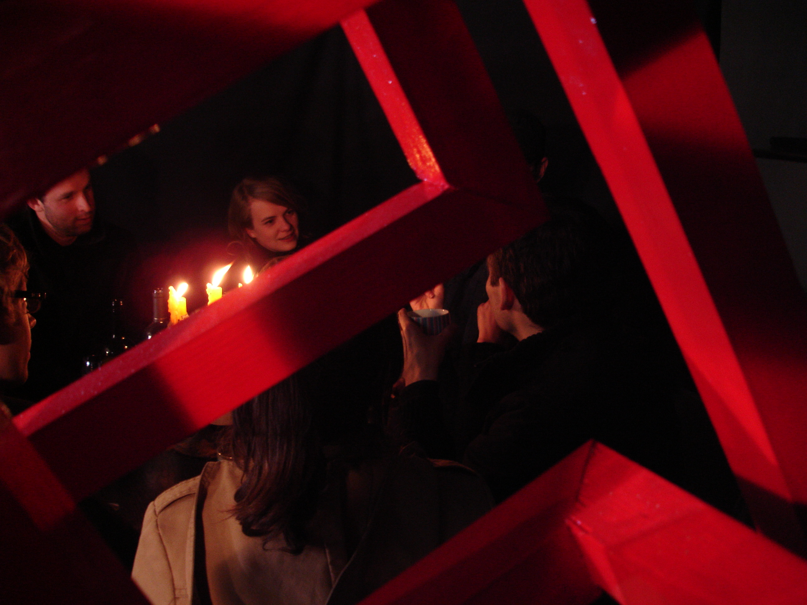
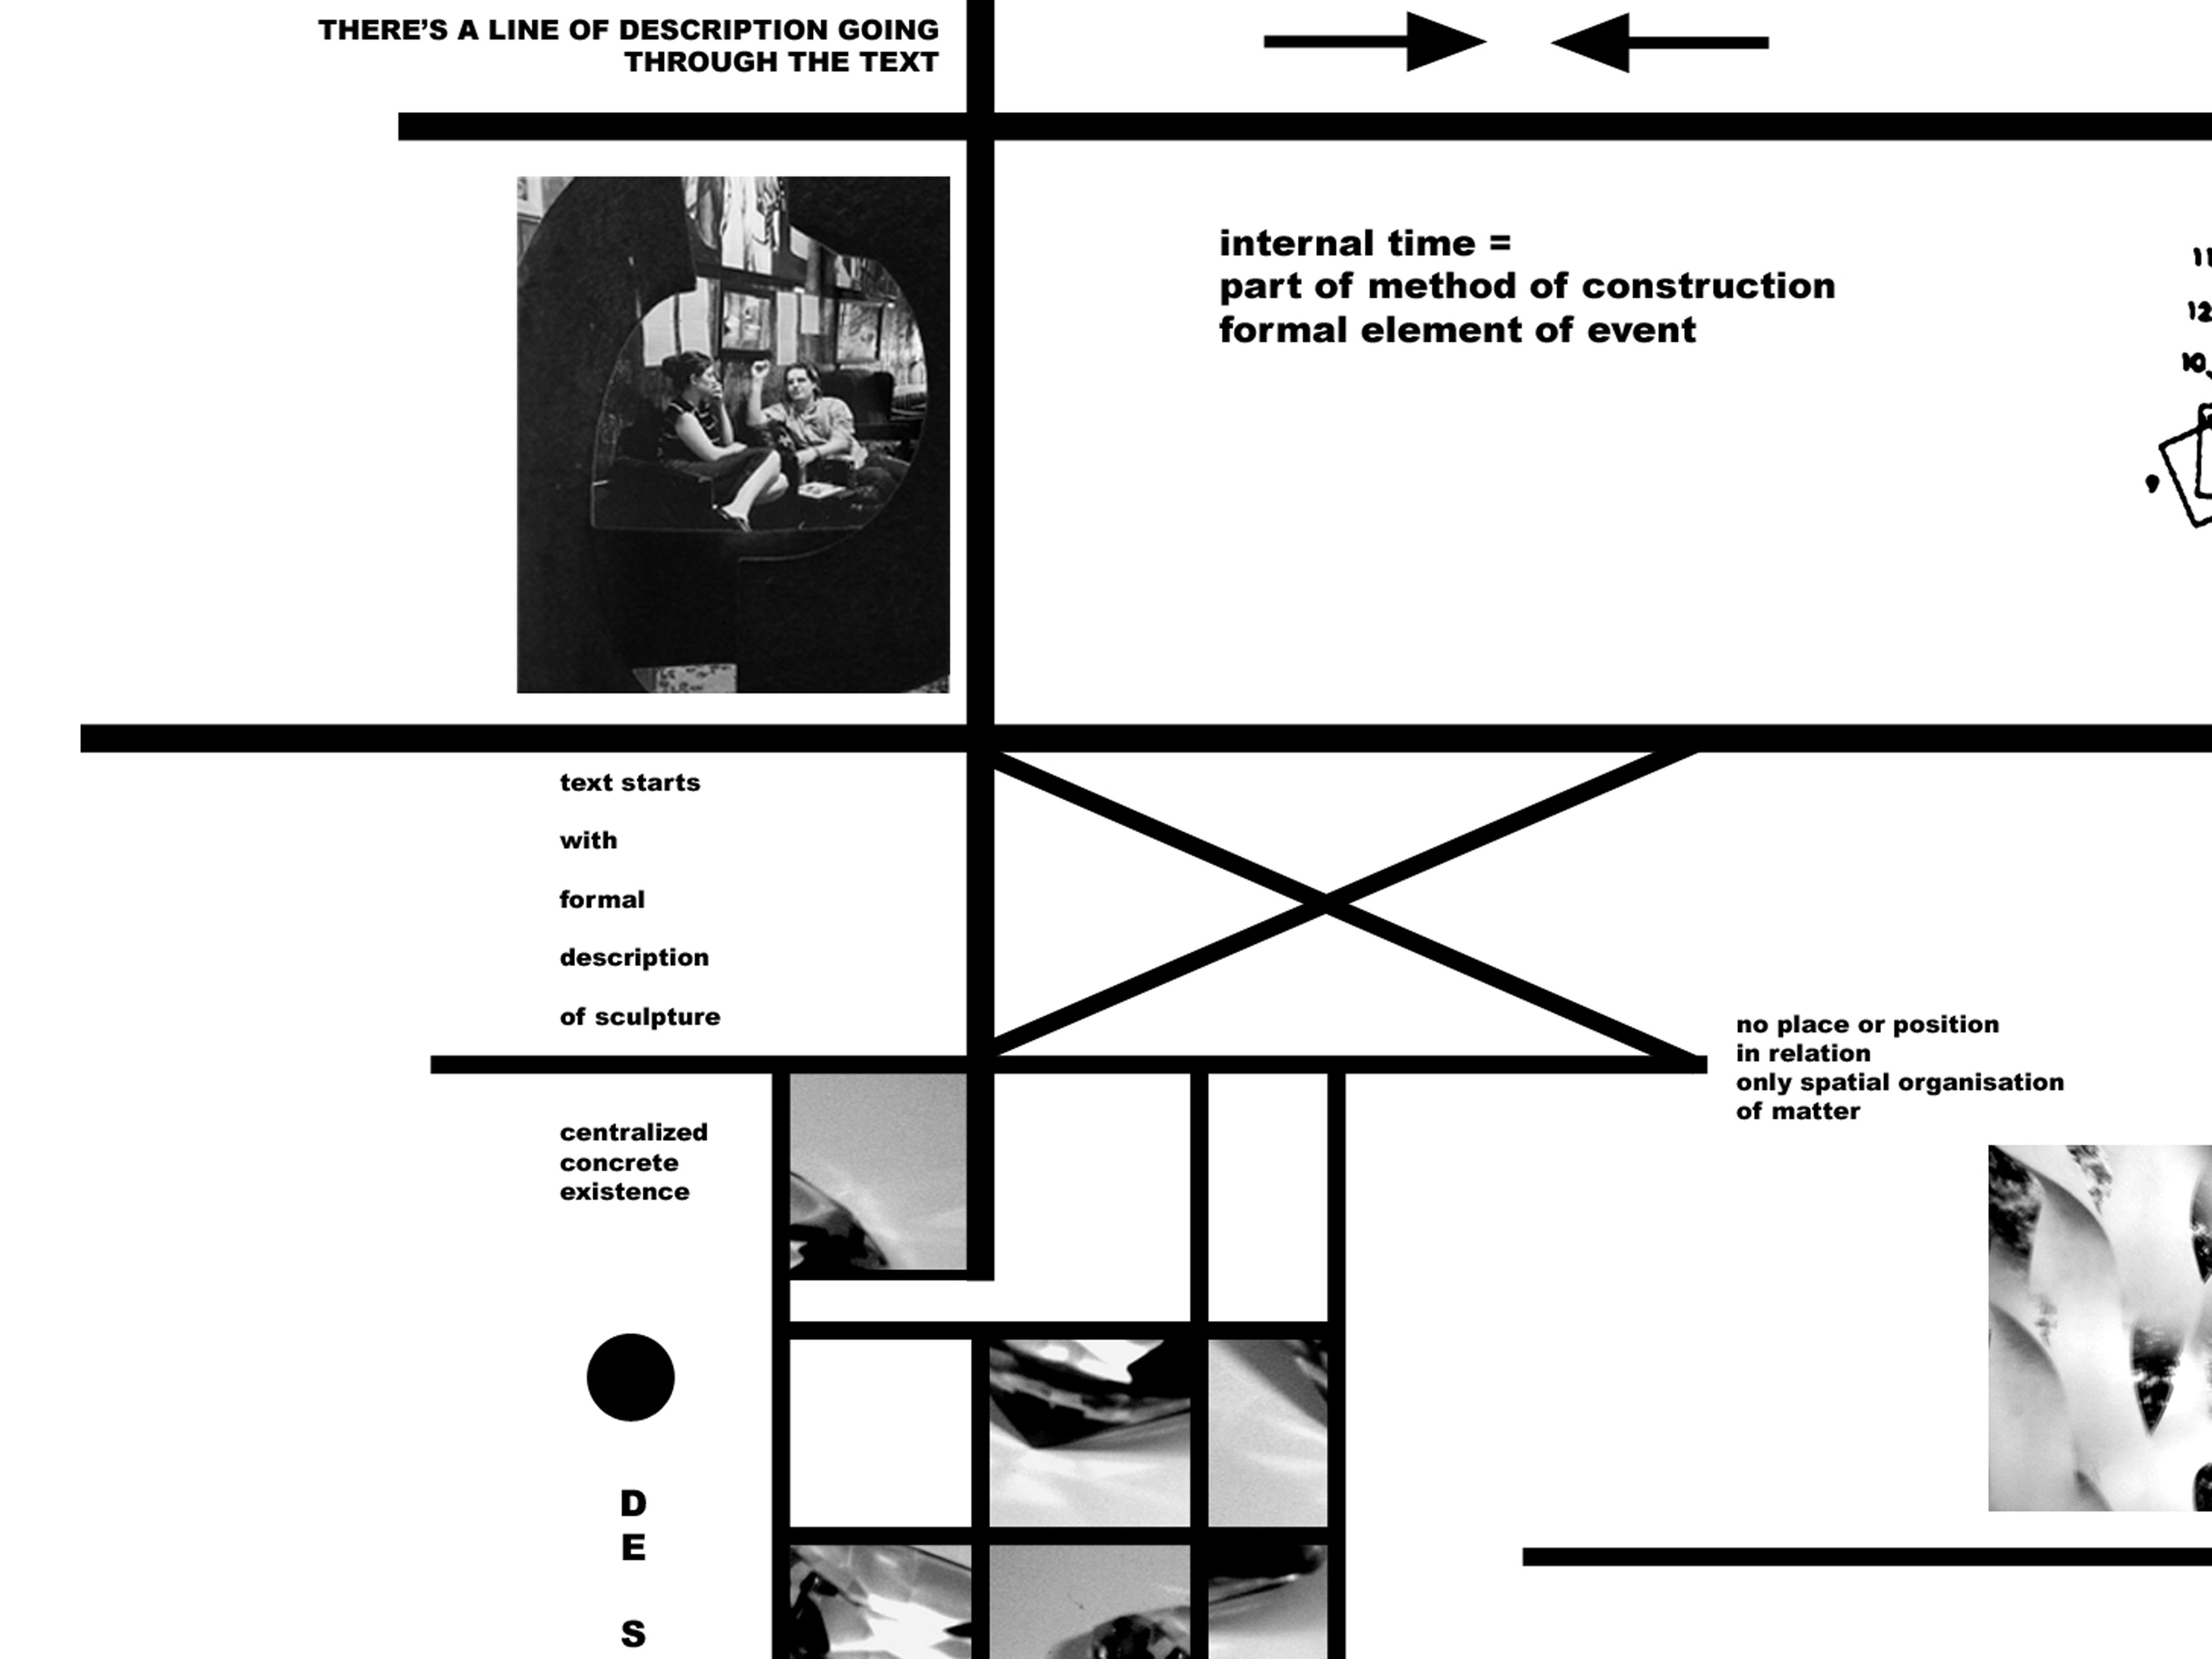

There’s a line of description going through the text. The text starts with the description of an artificial centralized existence, namely a sculpture – not even a real sculpture but one that is described in order to be turned into a conversation.

Description, which serves as the method of construction of the situation, covers the space from the sculpture to the conversation. The situation has an internal time which is part of the method of construction and one of the formal elements of the event. What is actually constructed – the transformation - is both a form and a moment, it is both a transformation of the form and a shift in time-space. In the construction through perception and description, this creates a space which begins, as Max Bill once wrote, on one side and ends in a completely different condition on the other side.

So the text starts with the description of an abstract sculpture. The sculpture is described and slowly dissolves into a conversation. The description is set up with the immanent transformation in mind and the need to incorporate, already in the sculpture, the possibilities of this transformation and to create the possibility to move from the formal of the sculpture to the content of the conversation.

The description is broken up into pieces. The ‘description components’ are built up individually; relative to each other and sometimes overlapping (although the appearances differ in their description). Shapes are perceived and constructed at the same time, providing a structure of images that potentially forms a unity: The perception fragments, which are obtained through the intentional visualization of possible perceptions and compiled to activate the physical properties of the object’s shape. Consisting of imagined fractional views of the object, with deliberate attention directed towards something that lies beyond the formal surface of the sculpture, they form propositional images that point to the potential of the sculpture.

