Artists’ Residency Programme (ARP)

The Process Room

West Wing, First Floor Galleries, Irish Museum of Modern Art

The Process Room facilitates access to the ongoing practice of artists currently on residence at IMMA. This residency programme is located in the studios adjacent to the main Museum building where several studios are allocated to both national and international artists. The Process Room is used on a rotating basis by the artists participating on the programme.
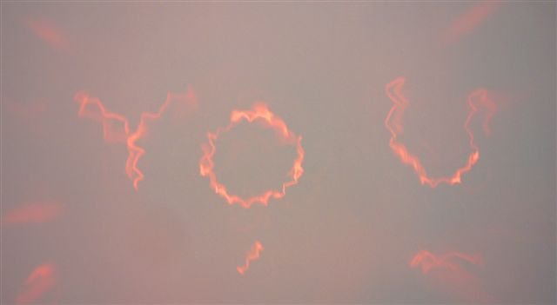
Ian Burns
Studio 11_Australia

04.08.09 - 16.08.09
Ian Burns. A promise of more, 2009.

On his residency at IMMA Ian Burns has been working on a series of new sculptures that investigate the power and phenomenological potentials of domestic appliances and objects.

It is rewarding when the lawn mower starts for the first time after its winter hiatus. It is a genuine pleasure when a table fan bought at the discount store exceeds its performance expectations - even better when it functions beyond its warranty period. It is awesome when 400 Watts of bass power perforates eardrums and loosens and crumbles that last bracket holding the exhaust system under the car. That magnifying glasses can be used to burn ants has never ceased to be a fascination.

Burns finds these simple phenomena deserving of focus and investigation. The new works, in finding new functions for the capabilities of everyday objects, walk a line that provokes the investigative impulses of curiosity at the same time as calling on the bafflements of the absurd.

Two larger works from this new series of sculptures are installed in the Process Room - a third may be added for the second week. The work, A promise of more, combines electric light, and the atmospheric color of the unique Irish ‘Fireglow’ light bulb, and the focal potentials of discount store magnifying glasses into a sculpture reminiscent of promotional signage for small town carnivals. This work directly identifies the viewer, projecting the word ‘YOU’ on to the gallery wall, constructing the characters from the individual bulb filaments into a humble welcome or a hasty accusation.

A Separate State is a major new work that is, as the title suggests, a self contained entity. This kinetic work draws its own power from the solar panel that is integrated into the sculptural form. This sculpture is mostly assembled from scavenged objects from around the IMMA site, brought together by technology to celebrate, in a ponderously slow flag waving demonstration, its existence. It references the visual cues of statehood, balance and justice and rejoices in the great traditions of those absurd functional sculptures of the past – fountains.

Burns (born Australia, lives and works in New York) has exhibited extensively with work in recent exhibitions at the Museum of Contemporary Art, Sydney, Australia, St Louis Museum of Contemporary Art, Museum Villa Rot, Burgrieden, Germany, Haus der Kulteren der Welt, Berlin and the University of South Florida Art Museum. He has had solo shows in New York, Vienna, Brisbane, Madrid, and had his first solo show in Ireland last year at Mother’s Tankstation, Dublin. His work is represented by Mother’s Tankstation, Dublin.

For more information about the Artists’ Residency Programme please contact Jennifer Phelan, ARP Co-ordinator, Tel + 353-1-612 9905 or jen.phelan@imma.ie Website www.imma.ie

