IMMA Artists’ Residency Programme (ARP)
The Process Room
West Wing First Floor Galleries Irish Museum of Modern Art

Action Event Object

23 March 2010 – 5 April 2010

Sally Osborn (ARP resident) will be making a number of interventions and performative gestures in relation to the painting Il Trovatore (c.1960) by Giorgio de Chirico.

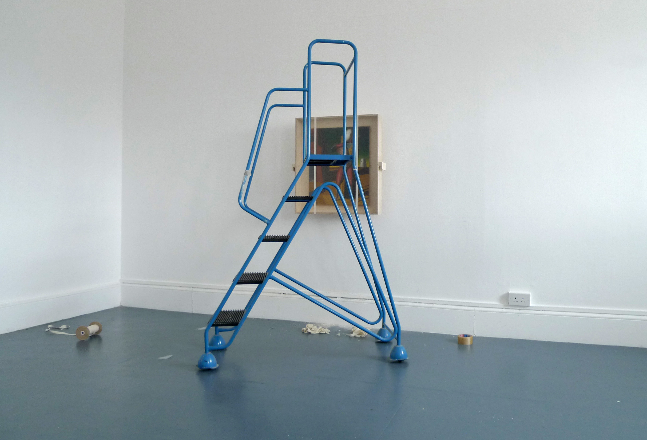

For more information about the Artists’ Residency Programme please contact Janice Hough, ARP Co-ordinator, Tel + 353.1.612 9905 or janice.hough@imma.ie Website www.imma.ie

